**Preliminary Work**

1. According to the objective and background information, draw an overall block diagram of the closed loop system and clearly indicate the signals and blocks.
2. What is the control objective? What are the possible disturbances?
3. An experimental data named heartbeat.mat is given to you. It contains the results of a bump test when the speed of the treadmill is constant at 10 km/h and slope is arranged as 15. Obtain the heart rate vs. time graph and approximate it as a FOPDT model. Simulate the step response of your estimated model around the operating point and compare it with the original data in the same figure.
4. What is the difference between servo control and disturbance rejection? Which one is more suitable for our purposes?
5. In this part, we will assume that there is no disturbance and we want to track the set point. Using ITAE formulas, design a P-only controller for servo control. Simulate the plant with the P-only controller with a changing set point between 160 and 180.
6. Using IMC correlations, obtain the PID parameters for moderate control. Simulate the plant with the PID controller with a changing set point between 160 and 180. Compare the result with part 5. Comment on the results.
7. Research and discuss the possible benefits of the heart rate control system. Give one example of the use of this structure.

**Answers**

**1)**

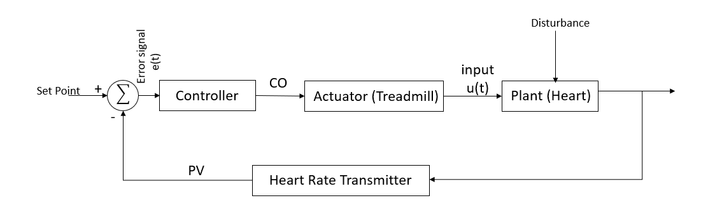

Figure 1: Overall block diagram of the closed loop system

(CO: controller output, PV: measured process variable)

**2)** The control objective is to keep the measured process variable (heart rate) at the set point under unmeasured disturbances. In this case, the disturbance might be anything related to human body such as hormones, blood glucose level, or even stress. Other activities like speaking while running also affects the process, so it might be counted as also a disturbance.

**3)**



Figure 2: Heart rate vs time for running with a speed of 10kph under 15 ° slope

Using the Figure 2, the FOPDT parameters are calculated as

$$K= \frac{∆y}{∆u}= \frac{179-81}{10-0}=9.8$$

$∆y/3=32.67$, $2∆y/3=65.3$, The output is equal to $y= y_{0}+\frac{2∆y}{3}=146.3$ approximately at time $t_{2/3}=24 ,$ and equal to $y= y_{0}+\frac{∆y}{3}=113.67$ approximately at time $t_{1/3}=10$ seconds.

$$τ_{p}=1.428x\left(t_{\frac{2}{3}}-t_{\frac{1}{3}}\right)= 1.428x\left(24-10\right)=20$$

$$θ_{p}= t_{1/3}-0.4xτ_{p}=2$$

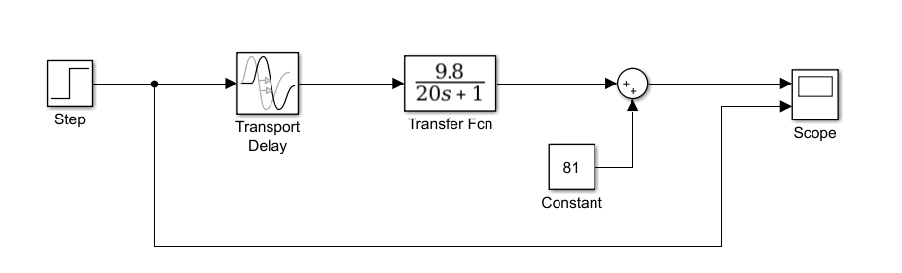

Figure 3: Simulink model of the FOPDT model of the heart

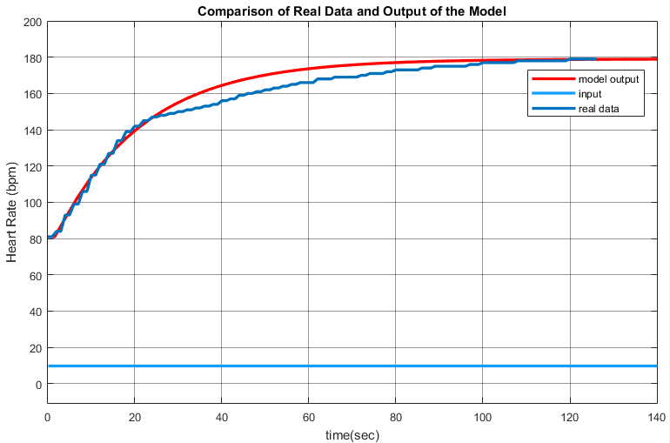

Figure 4: Simulation results with real data

**4)** Servo control is used for keeping track of changes of the set point while controller designed by using disturbance rejection formula is used for following a constant set point under disturbance. As there is unmeasured disturbance due to the nature of the human body, using disturbance rejection formula is more suitable assuming the set point will be constant.

**5)** For servo control:

$$K_{c}= \frac{0.202}{K_{p}} {(\frac{θ_{p}}{τ_{p}})}^{-1.219}$$

$$K_{c}= \frac{0.202}{9.8} {(\frac{2}{20})}^{-1.219}=0.341$$

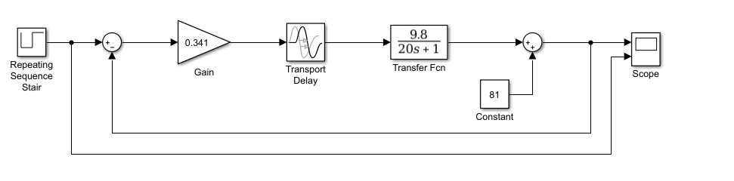

Figure 5: Simulink model of the process with P-only controller



Figure 6: Set point tracking using P-only controller

**6)** For moderate control : $τ_{c}=\max\left(τ_{p},8xθ_{p}\right)=20$

IMC formulas for dependent ideal PID controller:

$$K_{c}= \frac{1}{K_{p}}\left(\frac{τ_{p}+0.5xθ_{p}}{τ_{c}+0.5xθ_{p}}\right)= \frac{1}{9.8}\left(\frac{20+0.5x2}{20+0.5x2}\right)=0.102$$

${τ_{i}= τ}_{p}+0.5xθ_{p}=20+0.5x2=21$ seconds

$τ_{D}= \frac{τ_{p}θ_{p}}{2τ_{p}+θ_{p}}= \frac{2x20}{40+2}=0.952$ seconds

Hence, the controller parameters are calculated as:

$$K_{i}= \frac{K_{c}}{τ_{i}}=4.857x{10}^{-3}$$

$$K_{D}={K_{c}τ}_{D}=0.097$$

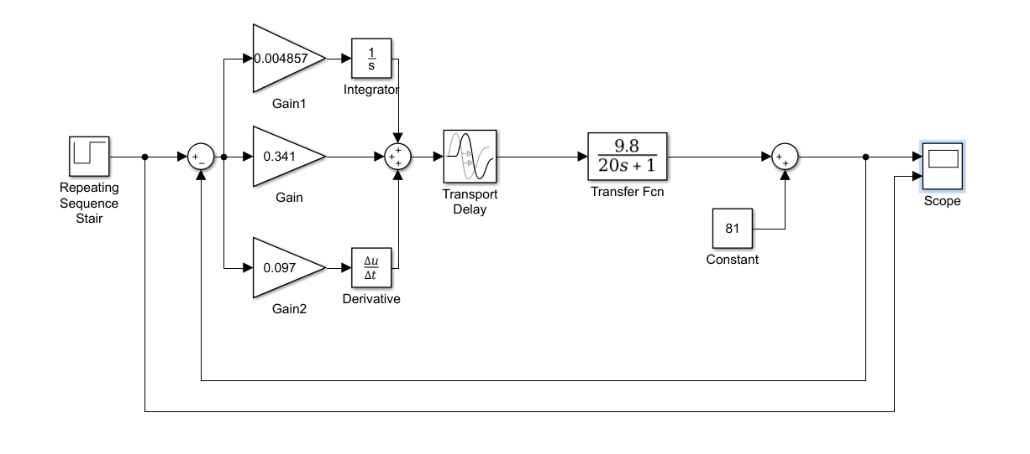

Figure 7: Simulink model of the process with PID controller



Figure 8: Set point tracking using PID controller

Comparing Figure 6 and 8, we can say that there are two significant differences. First of all, there is a nonzero steady state error with P-only controller, this error is reduced almost completely when we use PID controller. Secondly, the settling time is much larger when we use PID controller with this parameters. That’s why the simulation time is kept longer and in the second case.

**7)** Artificial control of the heart rate can be benefitial when the natural heart beat is stopped. In a healthy person, heart rate is controlled by the central nerveous system. When a problem occurs in this system (i.e. an accident which causes a damage on it), a redundant heart rate control system can be activated to maintain the oxygen distribution in the body. Also, people can adjust their own heart rate to feel warmer or cooler and to get rid off the sleepiness from the sedantive lifestyle. But, the manual adjustment should be done carefully and there should be some limitations to this application to prevent people to damage their hearts.